Campus Recruitment System
Abstract
The application campus recruitment is a web based application. Application will helps for the students and as well as the college placement. Students can easily get to know what are the placements in our college and as well as other colleges if they posted or alert by the placement officer. As per their aggregates students will shortlisted only the shortlisted students can get alert to their mails.
Objective
  - Produce high quality of software
  - Provide good services to the client
  - Instance solution
  - Easy to use

Introduction
A college campus recruitment system that consists of a student login, company login and an admin login. The project is beneficial for college students, various companies visiting the campus for recruitment and even the college placement officer. The software system allows the students to create their profiles and upload all their details including their marks onto the system. The admin can check each student details and can remove faulty accounts. The system also consists of a company login where various companies visiting the college can view a list of students in that college and also their respective resumes. The software system allows students to view a list of companies who have posted for vacancy. The admin has overall rights over the system and can moderate and delete any details not pertaining to college placement rules. The system handles student as well as company data and efficiently displays all this data to respective sides.

Methodologies:

E-R Diagram
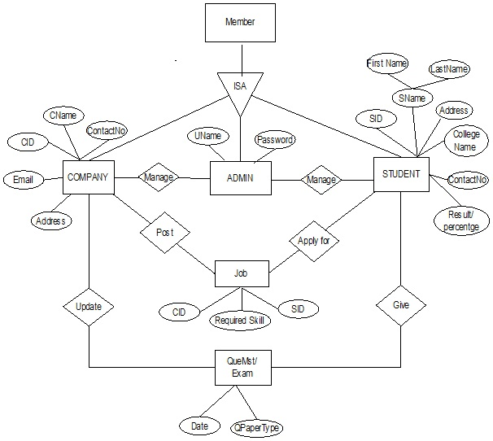

- flow chart diagram
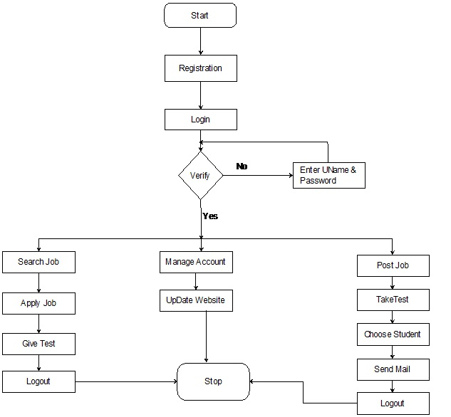

- Use Case Diagram
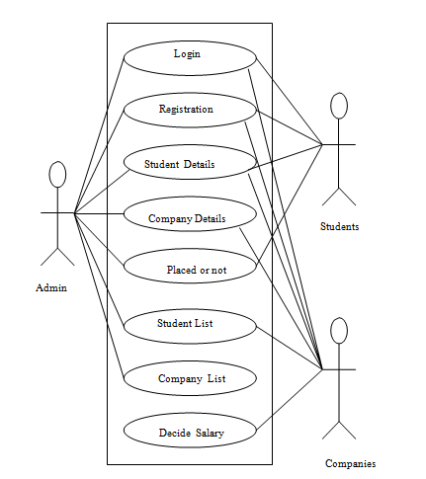

Modules:
- Admin Login
- Student Login
- Company Login

Software Requirements:

- Windows Xp, Windows 7(ultimate, enterprise)
- Sql 2008
- Notepad ++
- Wamp Server
Hardware Components:
- Processor – i3
- Hard Disk – 5 GB
- Memory – 1GB RAM

Advantages:
- There will be no need of putting up notice or emailing every student about the company coming in college. The students can keep updated themselves through this software.
- The company can view all students' detail and system can shortlist students according to their criteria instead of doing manually.
- There is admin login that can view and manage both students and company's account and also can put up notifications.
- Student can register online instead of going to placement department for registration.
- This system saves time and efforts.
Disadvantages:
- Student can't edit their application once sent. It would require admin to change the data.
- It requires large database.
Application:
This system can be used in all placement providing colleges for their campus placements. Also it can be used especially for a recruiting company.

References
http://synopsis.nevemtech.com/index.aspx?Id=P012
https://meeraacademy.com/online-campus-selection-system-in-asp-net-c-project/

